Coursework 3: life

Zhaoqi He k23004818

Trong Vu k22002090

Contents

A description of each life form 1

Amoeba: 1

Mycoplasma: 1

Diatom: 2

Challenge tasks 3

Reproduction: 3

Disease. 3

Non-deterministic cells: 4

# A description of each life form

## Amoeba:

* + Life span: 50 generations
  + Death condition: have >=3 aggressive around
  + Reproduction: At the last 2 generations of its life time
  + Defense Strategy: tit for tat
  + Disease behavior:
    - Never aggressive
    - Effects all surrounding cells
    - Life span shortens to 30

## Mycoplasma:

* + Lifetime: Infinity
  + Death condition: <2 or >3 alive cells around
  + Reproduction: never
  + Comes back to life when exact 3 neighbors
  + Defense Strategy: Never Attack
  + Disease behavior:
    - Turns aggressive
    - Dies after 10 simulation infected
    - Does not attack surrounding cells

## Diatom:

* + Lifetime: 12 cycle
  + Death condition: have >=2 aggressive around
  + Reproduction: every cycle with a 88% probability
  + Defense Strategy: Never Attack
  + Disease behavior:
    - With a 50% probability turning aggressive
    - Heals if there is 2 healthy cells
    - Dies after 5 simulation infected
    - Does not spread but contains in its children

## Mollicute:

* + Lifetime: infinite
  + Death condition: 7> or <2 alive cells around
  + Reproduction: reproductive every 10 generations
  + Strategy: Never Attack
  + Color change form red to black every other turn
  + Disease behaviour:
    - Dies if age 50 or higher

## Parasite

* + Lifetime: infinite
  + Death condition: <5 alive cells around
  + Reproduction: When Mollicute around
  + Strategy Conditional:

Only if nearby cell is a mollicute and cannot attack other parasites

* Disease behaviour:
  + - Become diseased at age 30
    - Become able to attack other parasites.
    - Contagious

We designed each cell so they have different characteristics.

Amoeba: Strongest cell in reacting to attacks but disease spreads quickly

Diatom: Weak but focuses on population and healing

Mollicute: Patterned behaviour and ignores surrounding attacks

Parasite: Targets Mollicute, and prone to other cells

# Challenge tasks

## Reproduction:

This Task is achieve in the simulator as it is on the same level with the populate() function.

Each cell has a reproduce flag. Every generation a cell with the reproduce flag calls this function.

I first find available spaces around the old cell and picks one in random. Then a new cell with the identical type is constructed with a switch to be placed in the field and the list to be looped though.

A new enum class is also created to represent the cell types.

## Disease.

Disease determined by two flags in each cell, disease and spread. Disease is determine the action of the cell with in and spread determines whether neighboring cells will be effected or not.

Example below is apart of the act() of the Amoeba cell:

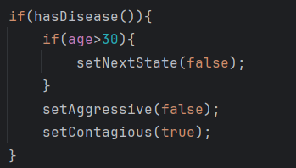

## Non-deterministic cells:

We implements a simple cell which has this feature: Diatom. It behave like a normal cell when it is attacked but it uses a random class each generation to determine if it wants to reproduce or not.

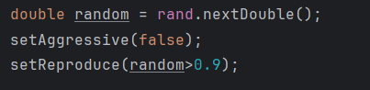

Further more, when it is effected by desease, it does not does not change behavior directly. It has a 50% chance of turning aggressive and attack neighboring cells.

## Symbiotic relationship

Parasite type cells has a symbiotic relationship with the Mollicutes cells.

They feed on Mollicute as they attack nearby Mollicute and grow when there are clumps of nearby Mollicutes.

However, Mollicute is only harmed in the relationship as they never attack and their reproduction is independent of other cells.